1. **Project Description & Objective**

This project is in lab format we need to compile and run the code by making the required changes and observe the insights for the changes made in the source code of the client and server programs provided. We chose the Linux platform to compile and run the code. The main objective of this project is to do experiments with TCP and UDP sockets. This project also includes the capturing of the packets using Wireshark application.

1. **Experiments with TCP sockets**

(a) Open two terminals. Start one server in one terminal and one client in another terminal. Make sure you are able to send messages from the client to the server. Leave both the server and the client running.

Answer:

->As mentioned started the server in one terminal using the below code

gcc simplex-talk-server.c –o 3aserver3a

./3aserver3a

->Start one client in another terminal using the below code

gcc simplex-talk.c –o 3aclient3a

./3aclient3a 192.168.1.106

Send messages from client terminal then those messages will be received to server.

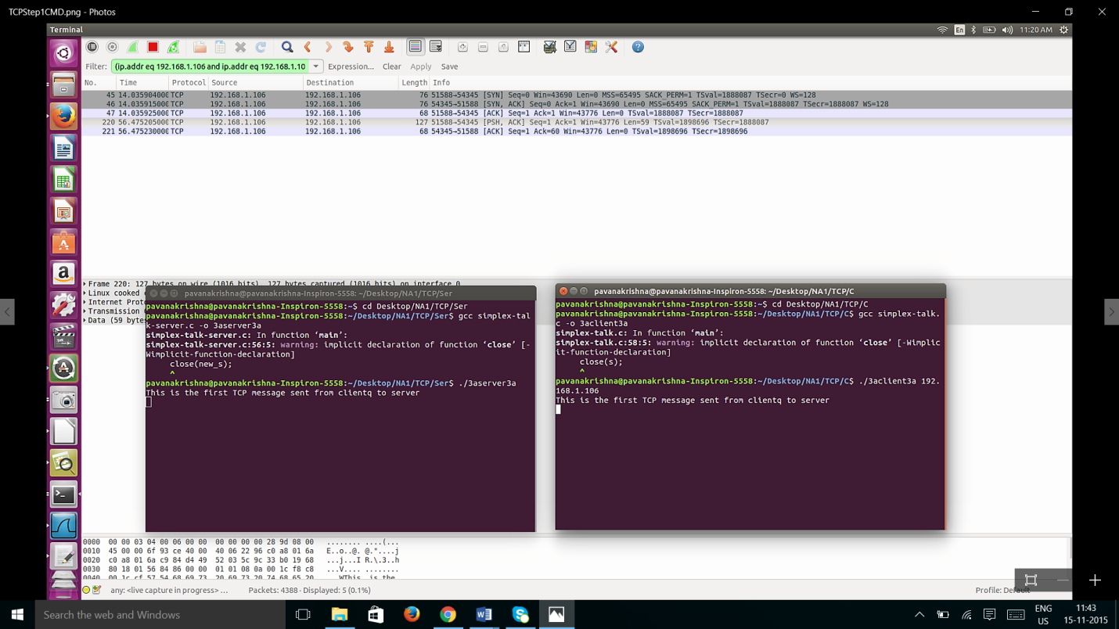

(b) Open a third terminal. Create a small file with a few lines of content. While

the first client is running, start nine other clients; these other clients should be

started in the background with their input redirected from a file. For example:

./simplex-talk localhost < smallfile &

Answer:

Step1:

Open another terminal (terminal3) and type the command given in the question as shown below to run the 9 clients in the background, but the messages won’t be transmitted to the server from those 9 clients.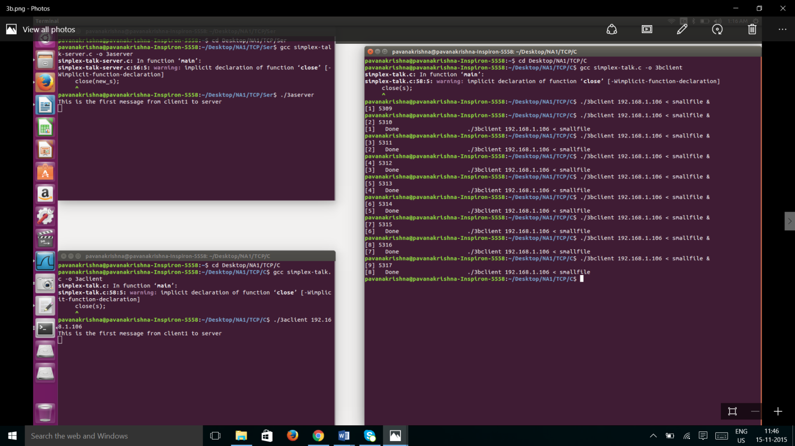

(c) Answer the following questions:

i. What happens to these ten clients?

Answer: After performing the above experiment we came to an observation that the server will accept messages only from the first client and will queue all the 9 max_pending clients.

ii. Do their connect () s fail, or time out, or succeed?

Answer: All the connections are success as we got the messages like Done.

iii. Do any other calls block?

Answer:All the clients are in connection with the server but the messages transmission is blocked in between the 9 clients and the server. Messages are transmitted only from the client terminal that is already in connected with the server as shown from ***Figure1*** and ***Figure2*** in Case2.

iv. Wait a bit, then make the first client exit. What happens?

Answer:

Case1:

We Waited for a few seconds and Closed the first client terminal then all the messages are transmitted to the server from the third terminal instantly from all the clients that are running in the background.

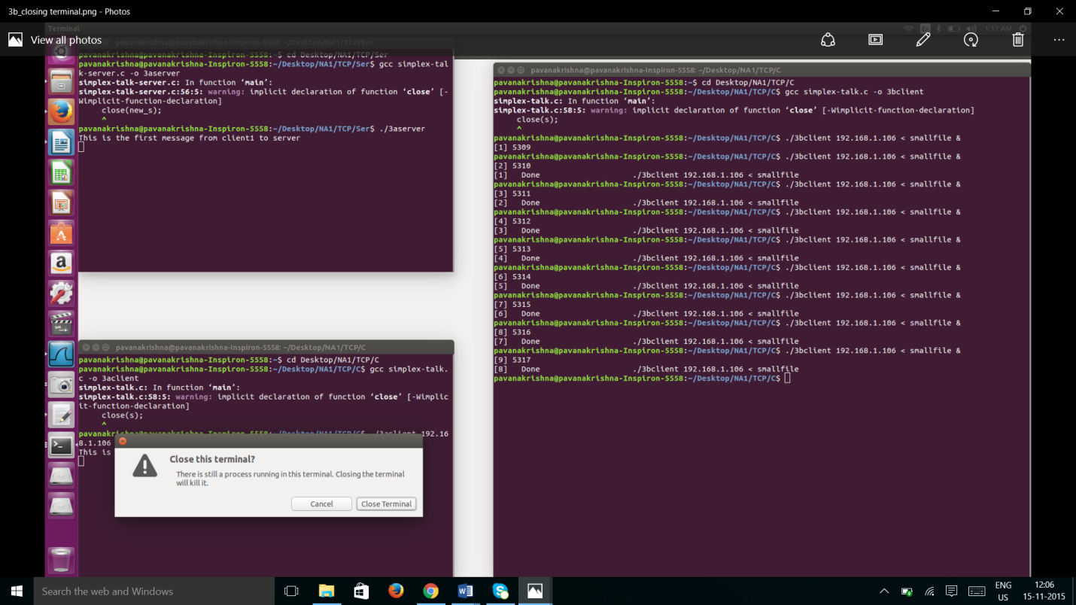

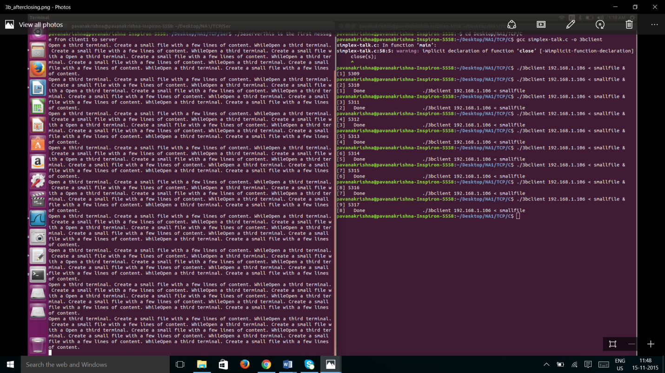

Case2:

After waiting some time if the First client is exited then only some of the messages are transmitted from the clients and remaining clients are timed out in the third terminal which are running in background. In this case only 6 are transmitted among the 10. See the below screenshots.

***Figure1***

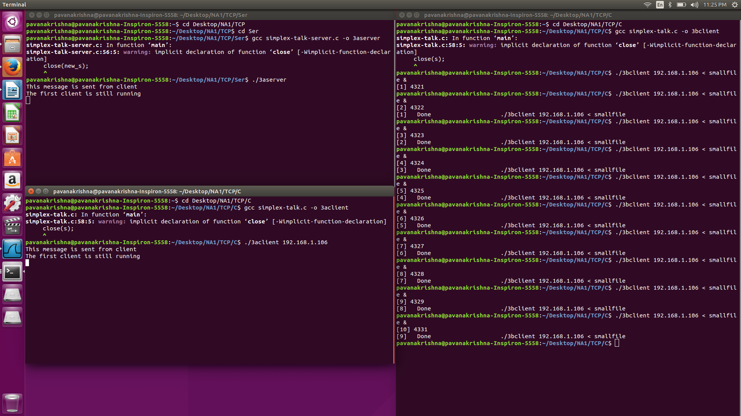

Only First Client sending messages are transmitted in the server and remaining messages send from background running clients are kept in queue

***Figure2***

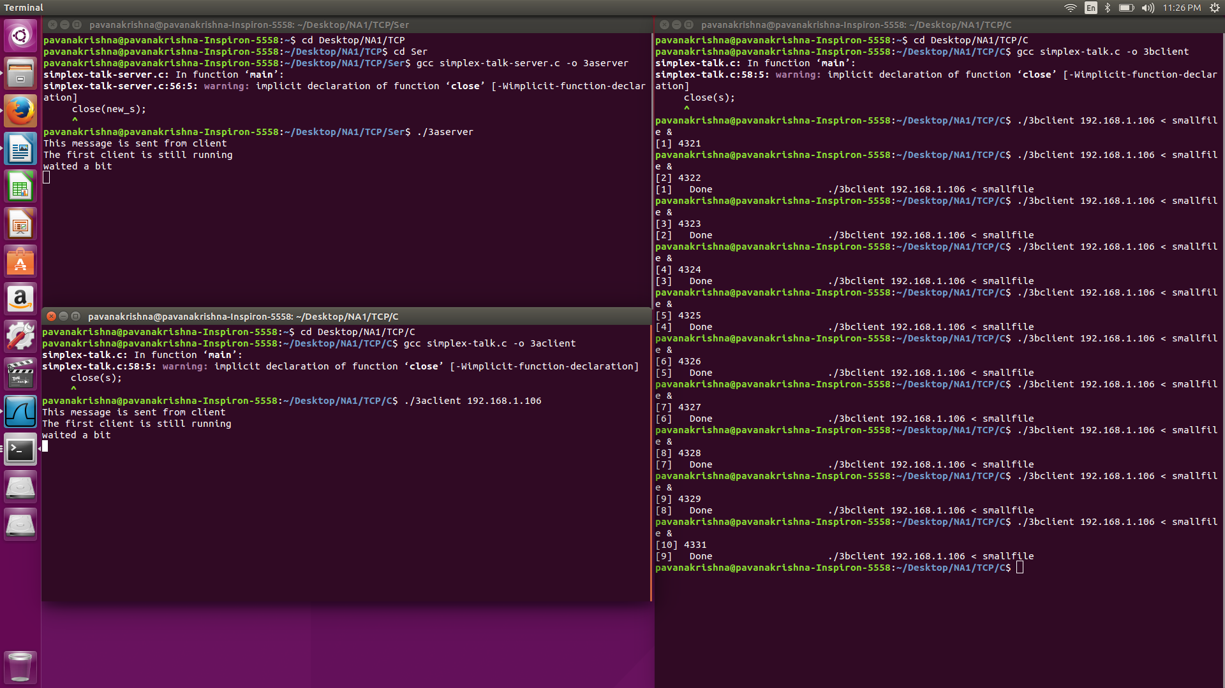

First client is exited

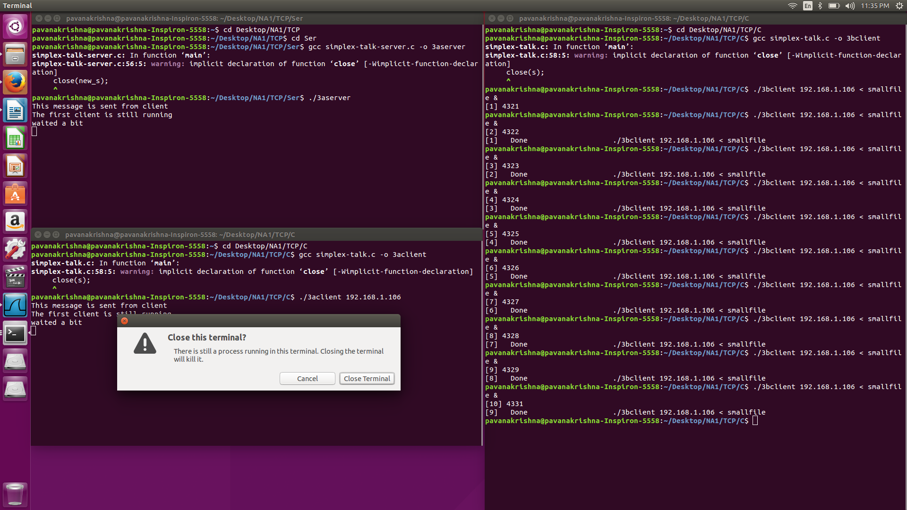

The following messages are transmitted to the server from Client, only 6 messages are transmitted from the third terminal. The remaining Clients are timed out hence those messages are not transmitted.

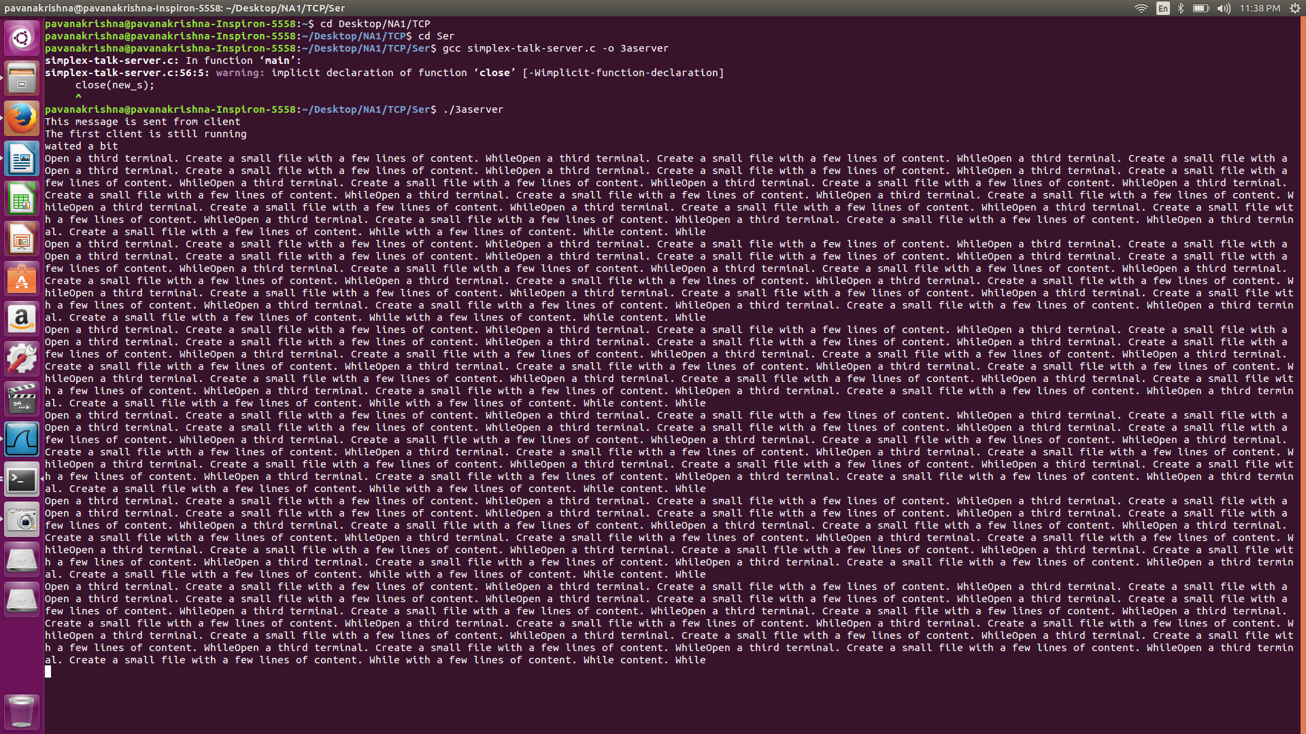

(d) Change the server constant MAX PENDING to 1 and recompile.

Answer:

The Significance of the MAX PENDING field is to define the connections that will be accepted and queued. In general, with MAXPENDING =1, one or two connections will be accepted and queued. The data won’t be transmitted to the server from other clients and they will be ignored and they will be timed out. When the first client exits, any queued connections are processed.

(e) Open two terminals. Start one server in one terminal and one client in another terminal. Make sure you are able to send messages from the client to the server. Leave both the server and the client running.

(f) Open a third terminal. Create a small file with a few lines of content. While

the first client is running, start nine other clients; these other clients should be

-started in the background with their input redirected from a file. For example:

./simplex-talk localhost < smallfile &

Solution:

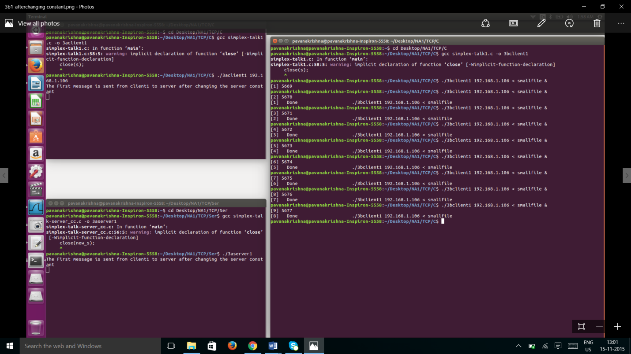

(g) Answer the following questions:

i. What happens to these ten clients?

Answer: After performing the above experiment we came to know that the server will accept messages only from the first client and has queued only 2 max_pending clients though all the clients running in the background are appeared to be same as when max_pending is 5. (this is identified after closing the client terminal connected to the server)

ii. Do their connect()s fail, or time out, or succeed?

Answer:

All the connections are succeed as they are replicating the same behavior as shown when MAXPENDING = 5. But once the first connected client is exited only one or two clients will be connected from the queue &all the remaining clients are ignored as MAXPENDING =1, only one or two clients will be accepted and queued.

iii. Do any other calls block?

Answer: All the Calls are blocked and the server is not receiving data from any of the clients that run in background and it is receiving only data from the first client as earlier. Only 2 client’s connections are accepted and queued.

iv. Wait a bit, then make the first client exit. What happens?

Answer:

When first client is exited then only two messages are transmitted from the nine clients and the remaining 7 clients are ignored and the message transmission is not done and they are timed out as shown below.

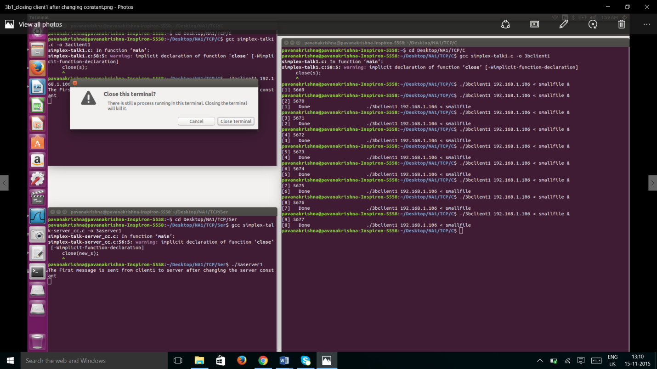

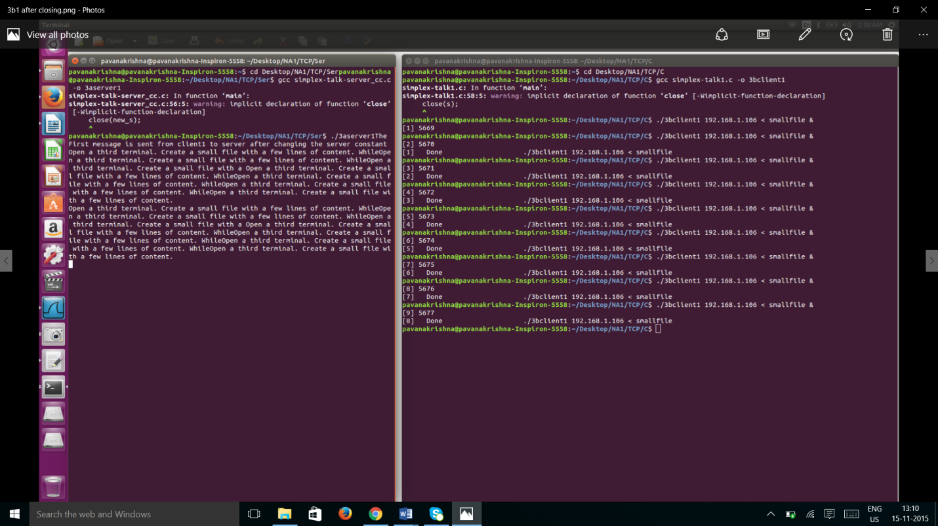

(h) For this part of the lab, you will need a second host, one will be the client and

one will be the server. Since this part of the lab requires Wireshark, make sure

you do this on your home network and not the campus network.

(i) Under the Capture menu, choose Options. In the text field labeled Capture filter, type “tcp port xxxxx” (fill in the port number you have chosen and use no quotes). Then click the” Start” button.

(j) Start the client on one of the hosts. Type several messages. Type one very long

message (at least 6 lines) without hitting Enter. Quit the client and stop the

capture.

**Answer**:

Client in First Host

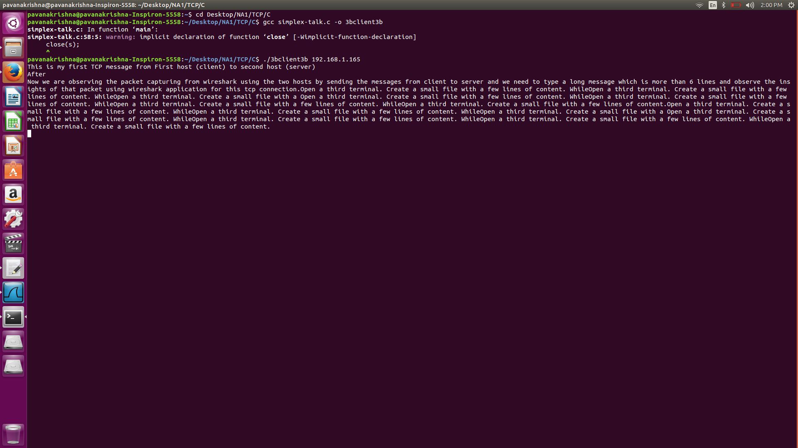

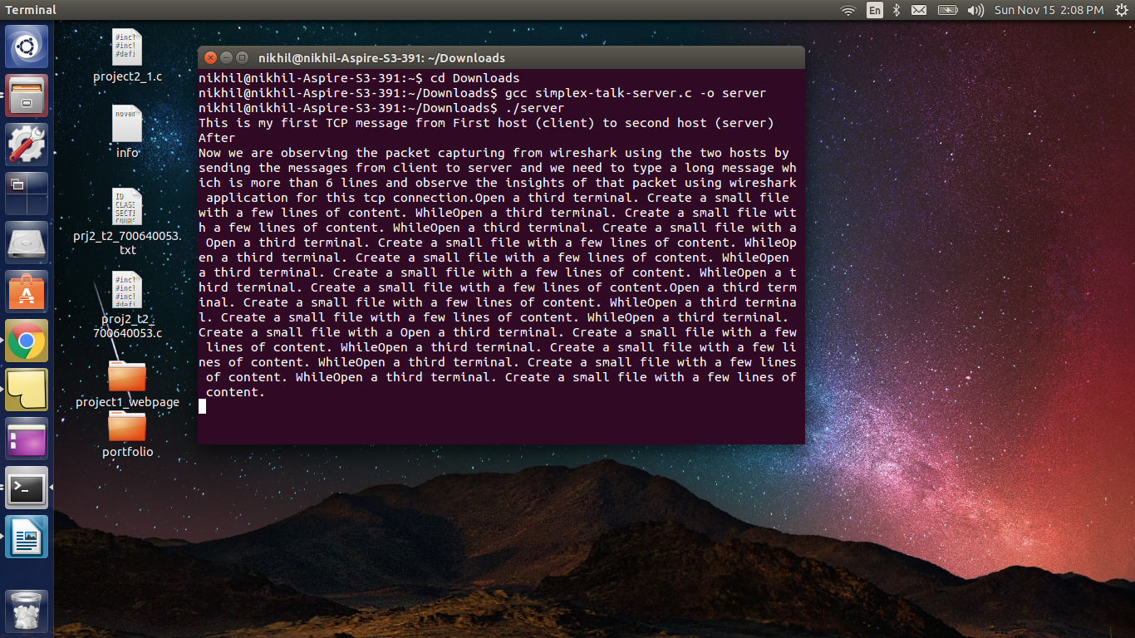Server in Second Host

Client is closed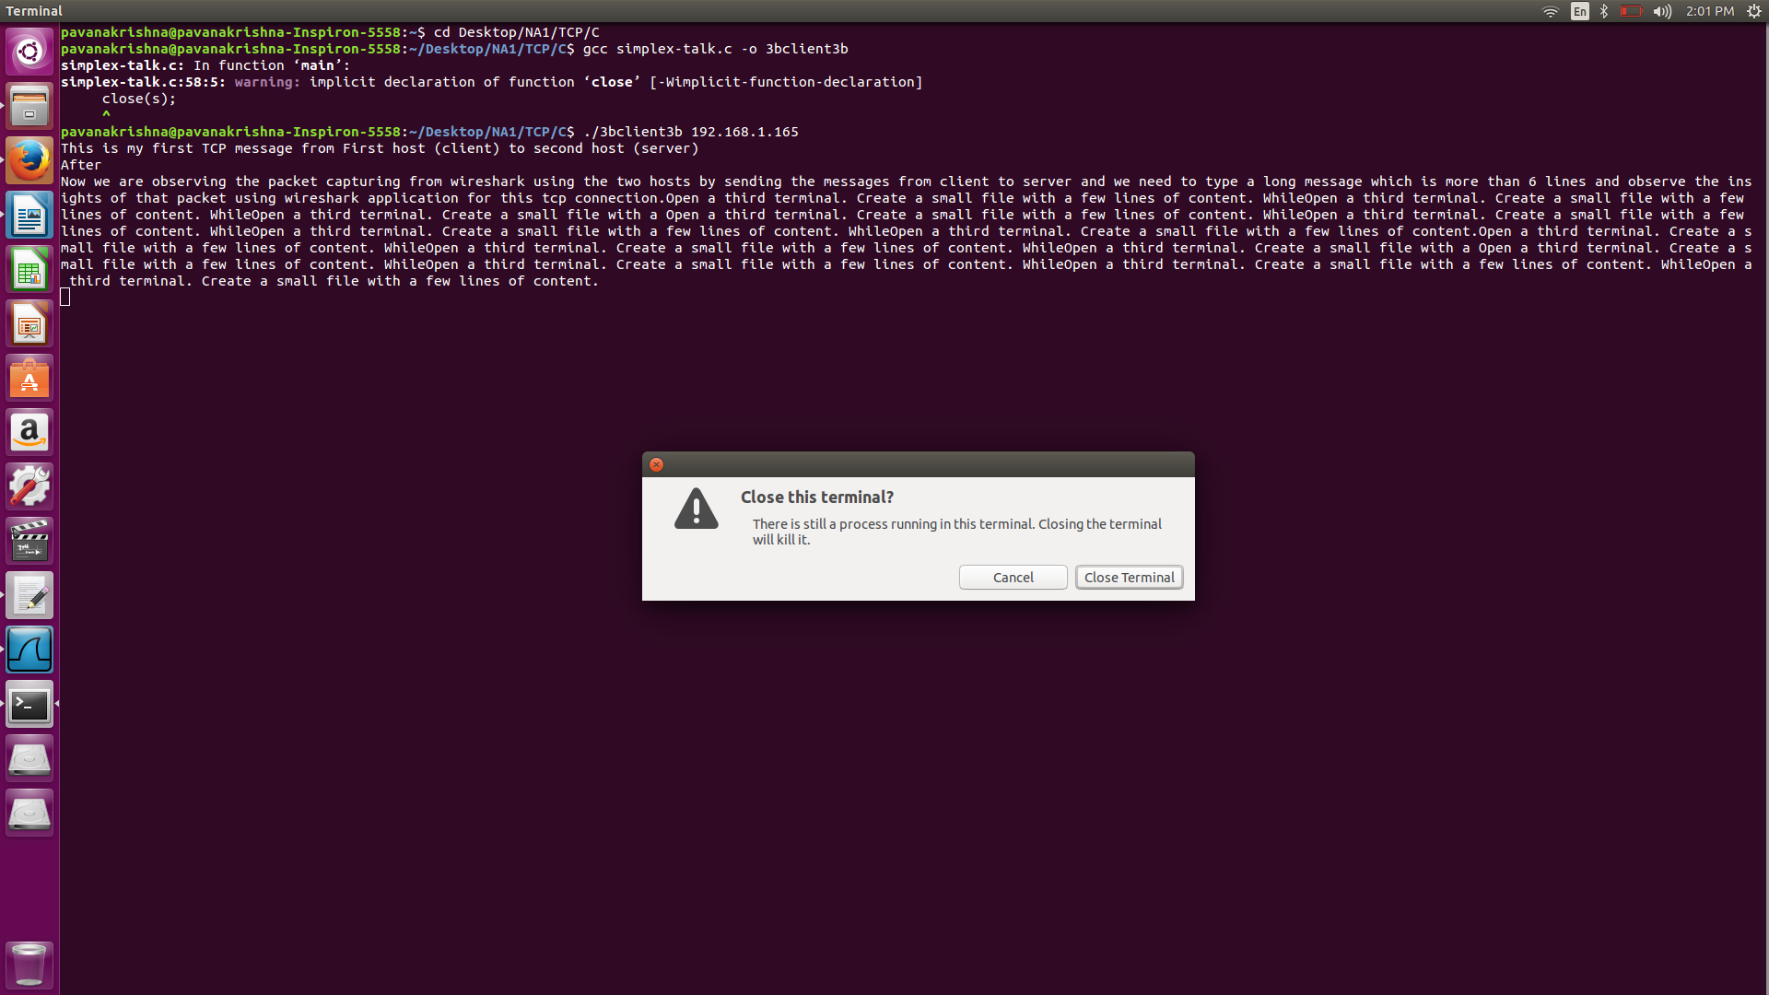

(k) Answer the following questions

i. How many packets were transmitted?

Answer: Total packets of 14 including the acknowledgements from server, connection establishment and closing the connection.

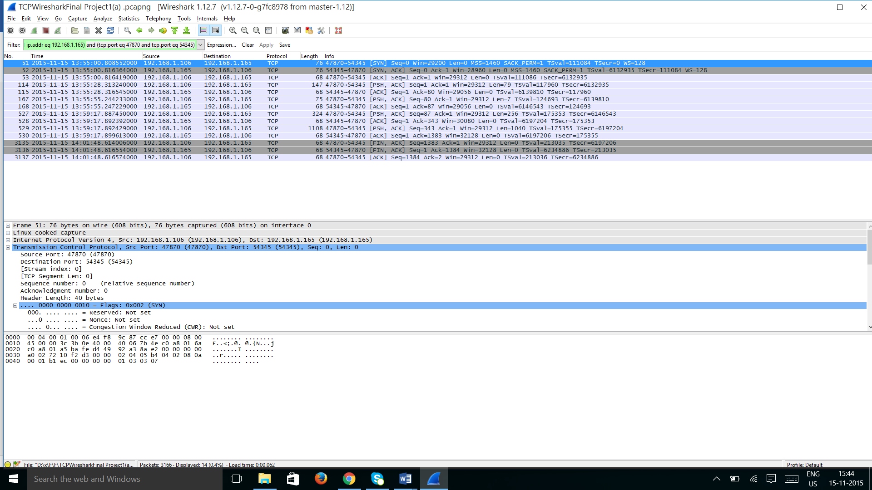

ii. What is the correspondence between messages and packets?

Answer: There are 4 [PSH,ACK] packets are corresponded to the 3 messages sent from client to server which are of TCP segment lengths 79,7,256,1040 respectively.

Client IP address is 192.168.1.106

Server IP address is 192.168.1.165

“After” Message in sending request from client to server is highlighted below. Similarly, other messages have also [PSH, ACK] packets are available.

All [PSH,ACK] packets sent from client are acknowledged by server through [ACK]

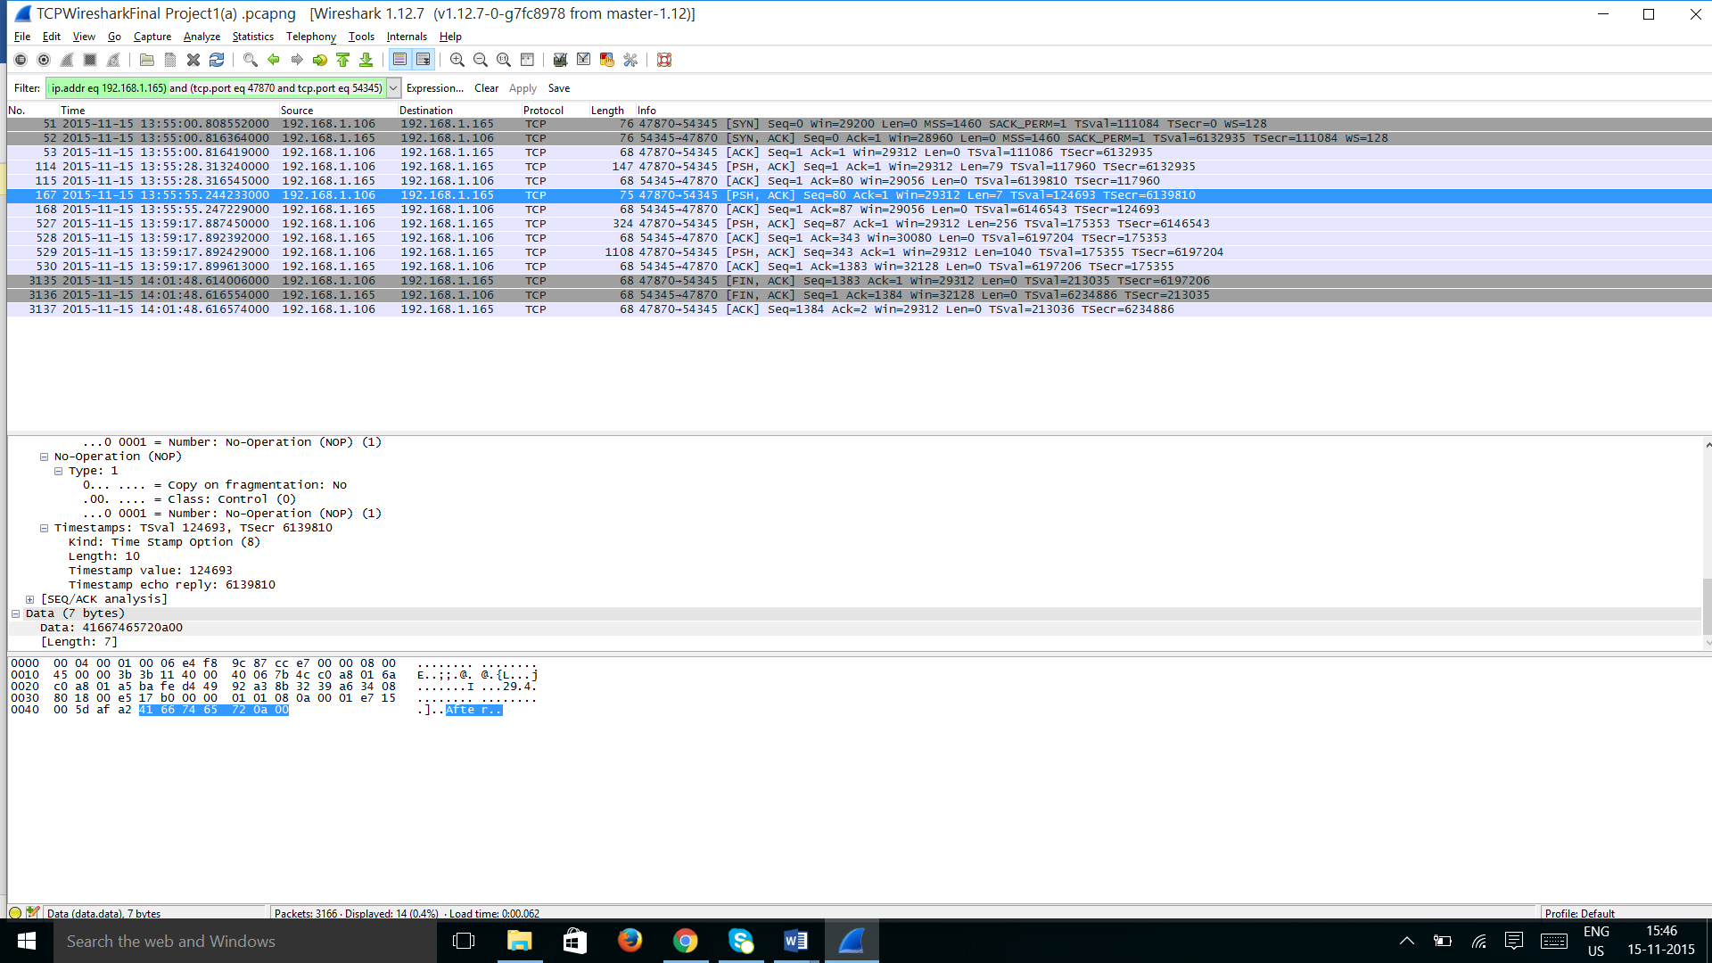

(l) Modify the client and server so that each time the client sends a line to the server,

the server sends the line back to the client. The client (and server) will now have to

make alternating calls to recv() and send(). Verify that this new version behaves

as expected.

1. **Experiments with UDP sockets**

(a) Modify the simplex-talk client and server so that it uses UDP as the transport

protocol, rather than TCP. In both client and server, you will need to change

change SOCK STREAM to SOCK DGRAM.

(b) In the client, remove the call to connect(). Rather than using the send() syscall,

use the sendto() syscall, which requires you to provide the destination address with

each buffer that you send. (This better matches UDP’s connectionless datagram

model.) Note: This suggestion is from Janet Davis at Grinnell College.

(c) In the server, remove the calls to listen() and accept(), and replace the two nested

loops at the end with a single loop that calls recvfrom() with the socket s. (Using

recvfrom() allows the server to learn who has sent each packet, even though there

is not a connection.)

(d) What happens when 2 or more clients connect to the same UDP server?

Answer:

Client Code

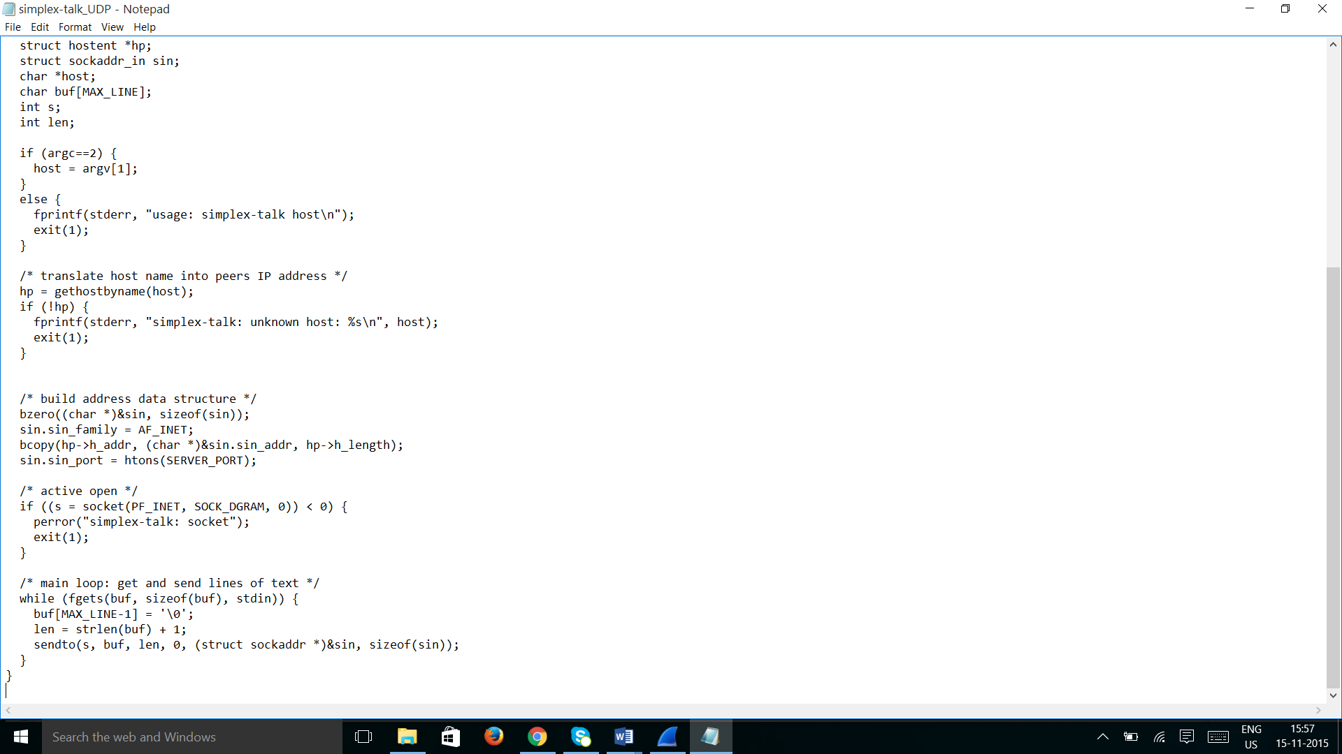

Server Code

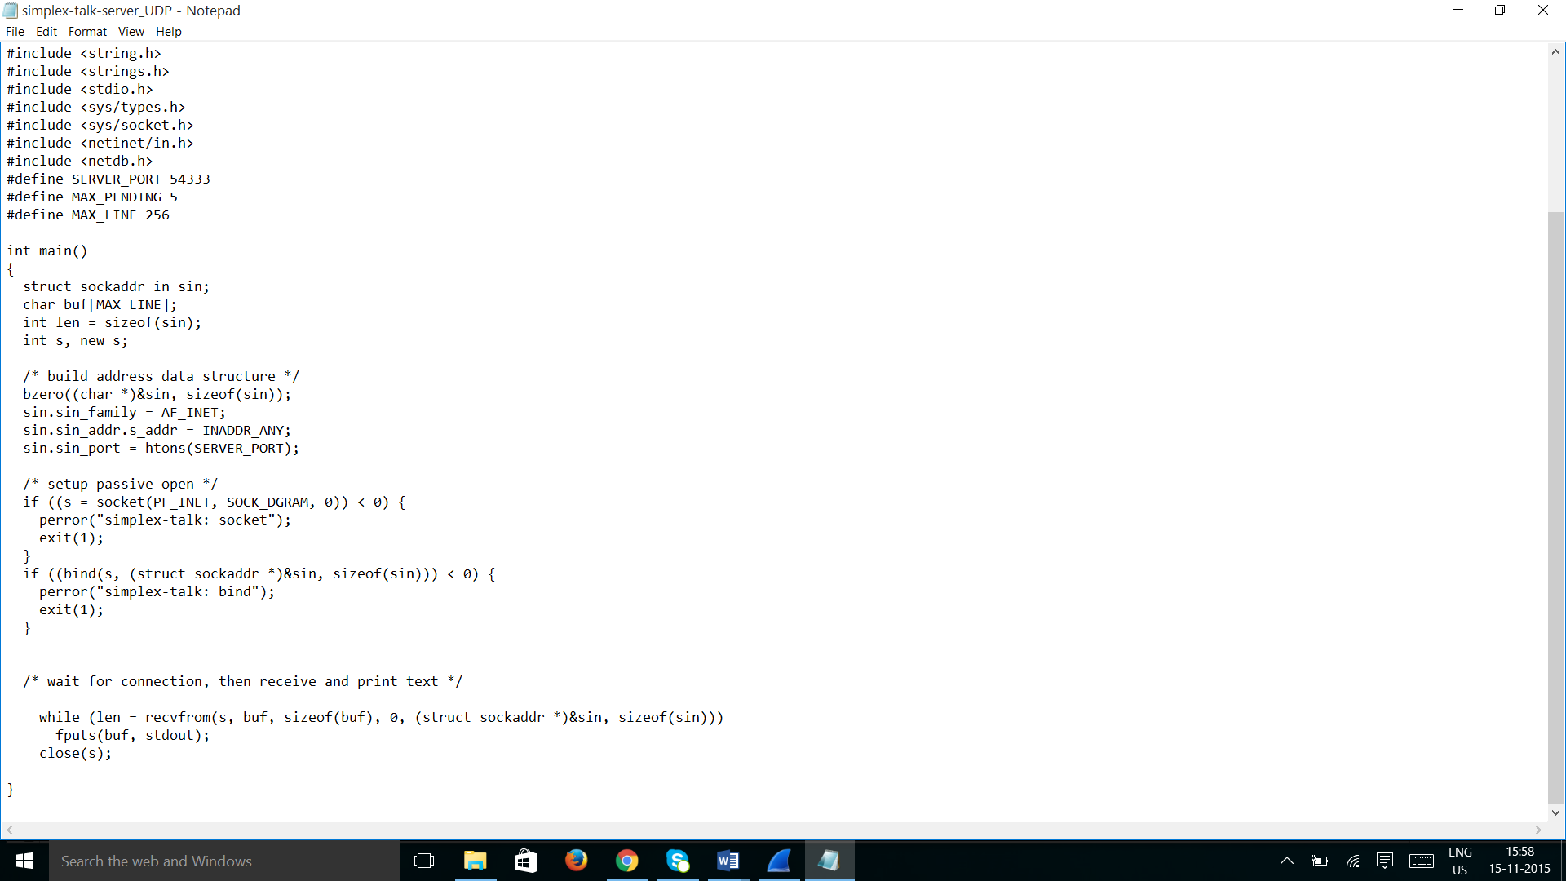

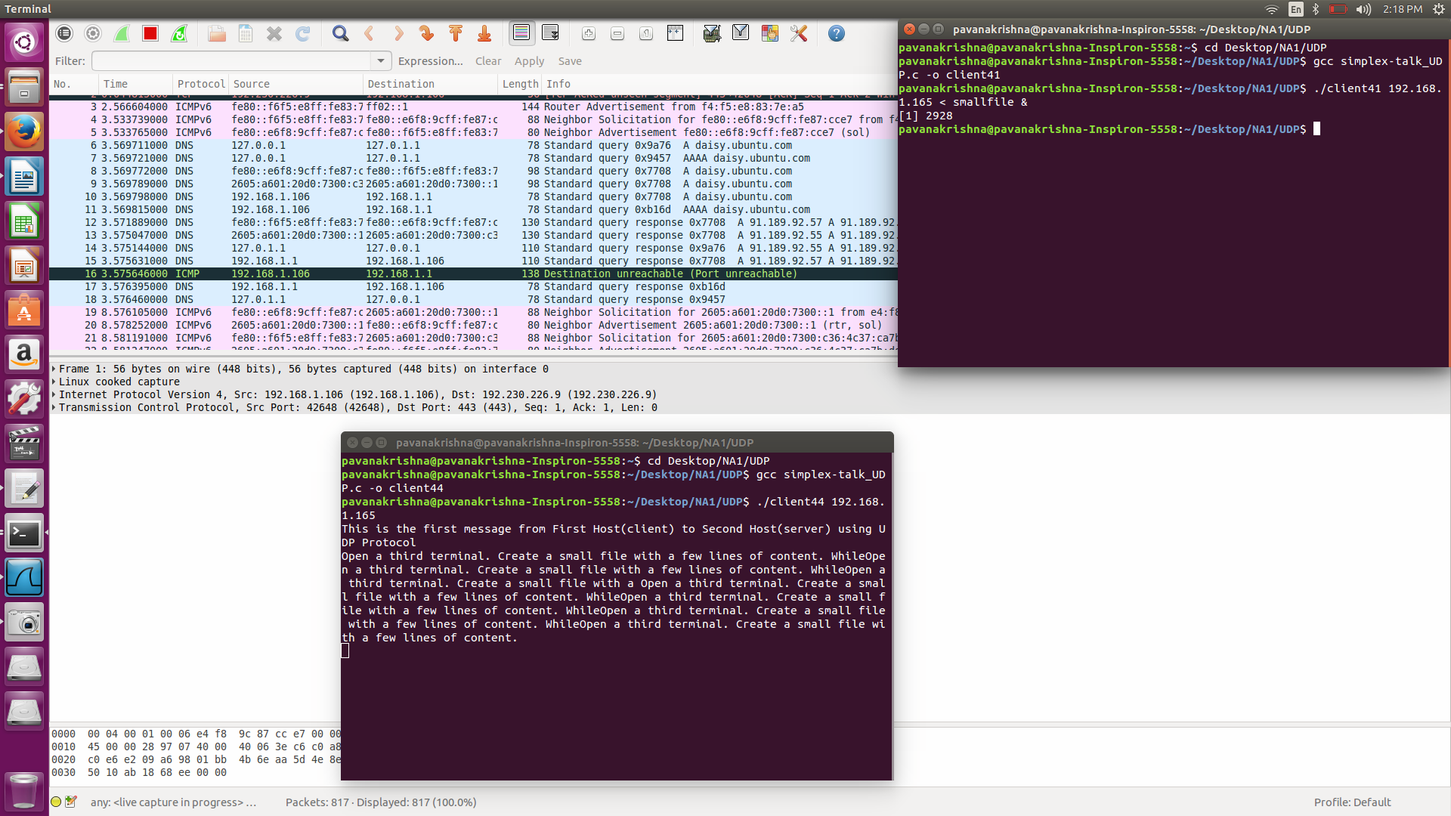1 UDP Client running in background and other is already connected to the server

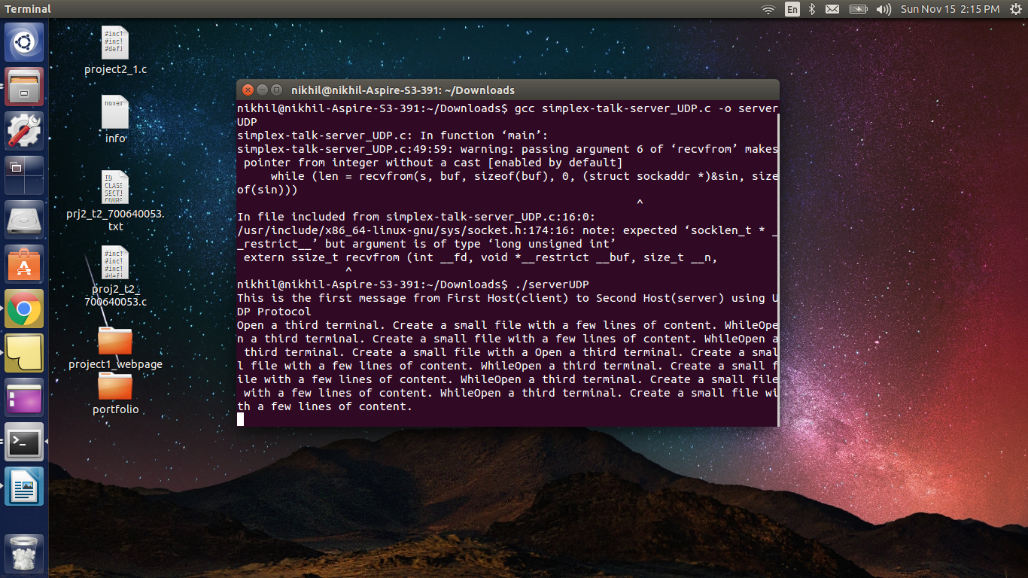UDP Server

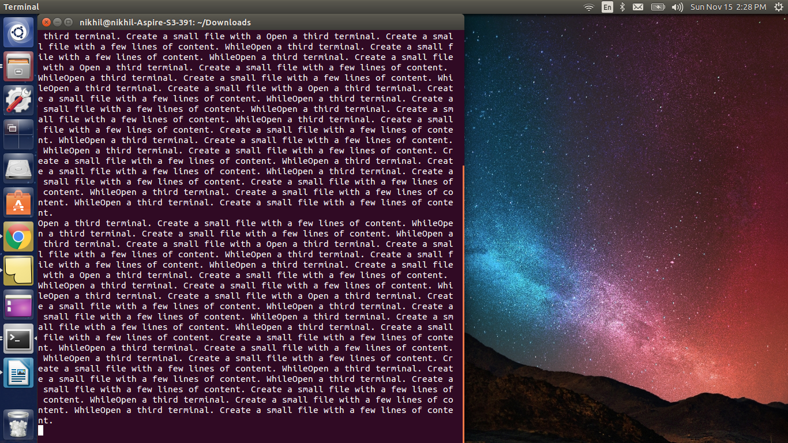

Using UDP protocol we can send the messages from multiple clients to the server without any blocking as shown above, using two clients one running in the background and other already connected to the server. Both messages are received in the server end.

Closing the Terminals and Stopping the wireshark

(e) How does this differ from TCP behavior?

Answer:

Using UDP protocol we can send the messages from multiple clients to the server without any blocking or queueing of the messages where as in TCP we can only send messages from the first client which is connected to the server and the remaining clients running in background will be in Pending Queues. Once the first client is exited the pending queues which are not timed out will transmit the messages to the server.

**UDP:**

All the messages send from various client terminals are received to the server. Below one is a screenshot for the reference

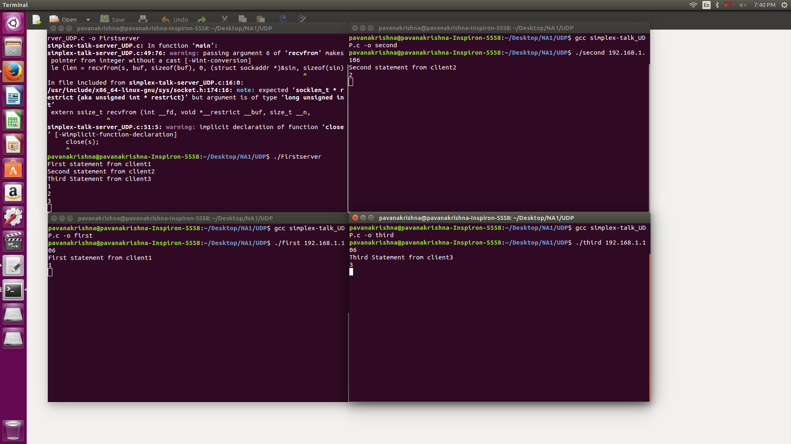

**TCP:**

The messages send from the client which is connected first to the sever are only received and the remaining messages from the other client terminals aren’t received.

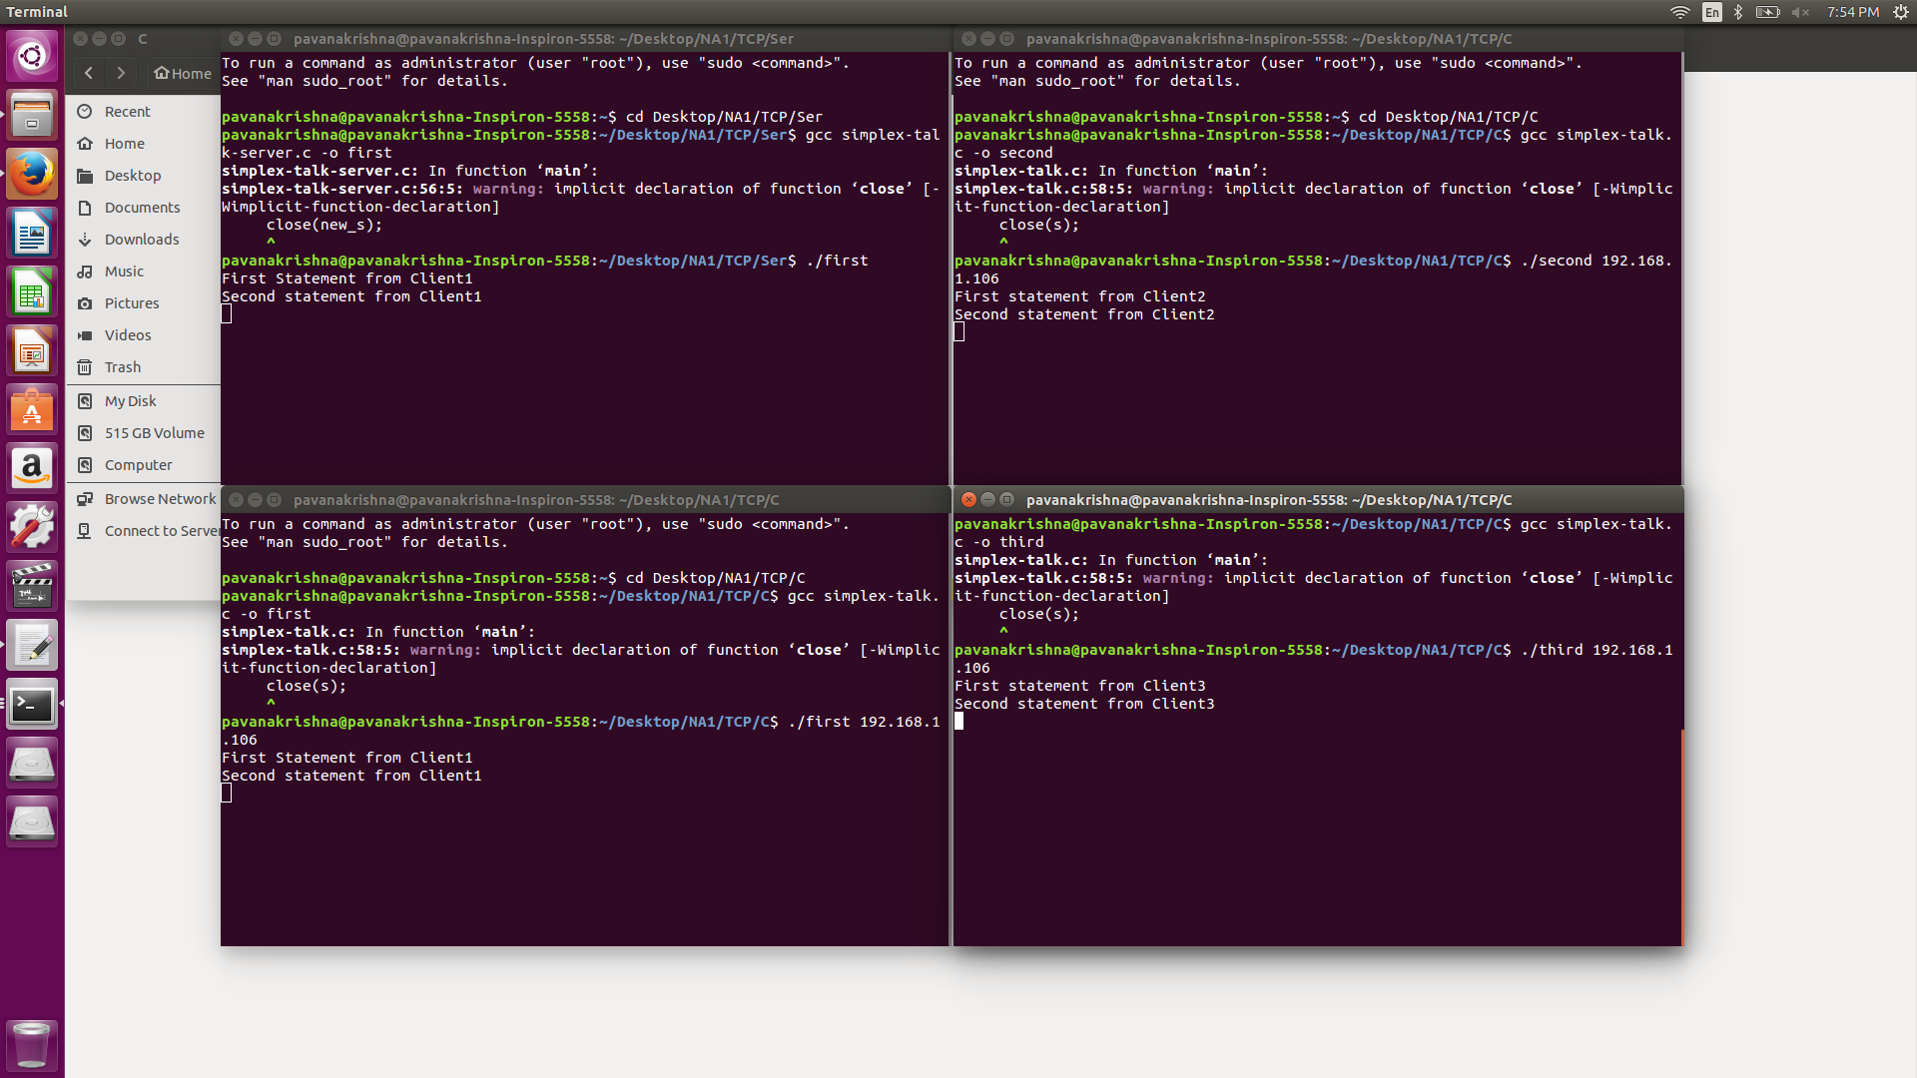

5) Turn in question answers along with screenshots from wireshark all in a single .pdf or word file

Answer:

Server Address is 192.168.1.165

Client Address is 192.168.1.106

The messages sent from the client to the server and later opened another terminal and send the data using the small file as input from that client. Hence it is evident that there are two source ports.

The data send from port 55582 is the first line sent from the first client connected which is of length 121 including the header length. Similarly, other messages are also recorded.

Since we used input as small file from the client it has different source port and the total number of packets captured as 9 for 3 messages. 6 packets alone used to send the small file input using 48207 source port.

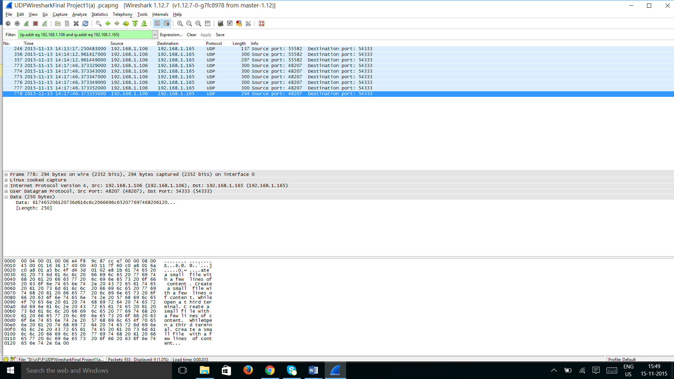

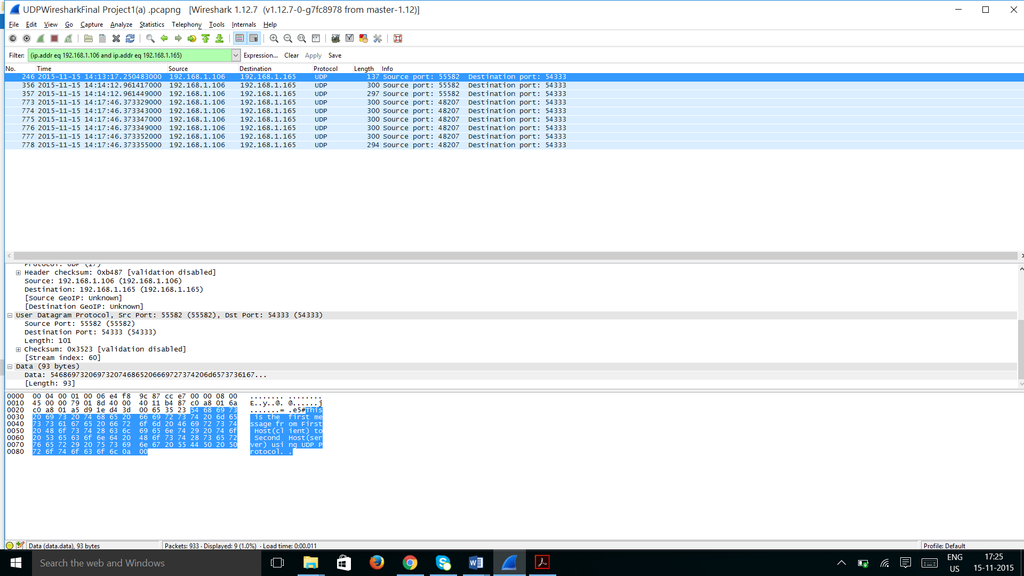

**Edited Source code files used for UDP**



**Wireshark files of UDP & TCP**

